Design by Jimmy Sherpa

Batch 22 ‘B’

Design

Design is the process of creating a model for a system which we have in our mind. It helps us in creating a depth view of the system we are about to create thus helping in the development of a system or software. The better the design, the better the software is going to be.

Structural Design

Flowchart, DFD (Data Flow Diagram) and Class Diagram are known as Structural designs as they help us view the structure of a system. Therefore, Structural design can be defined as that which represents the structure and behavior of a system.

Final Class Diagram

A class diagram defines the relationship between classes or can be view as a structural representation of a system. It helps us to observe a system properly.

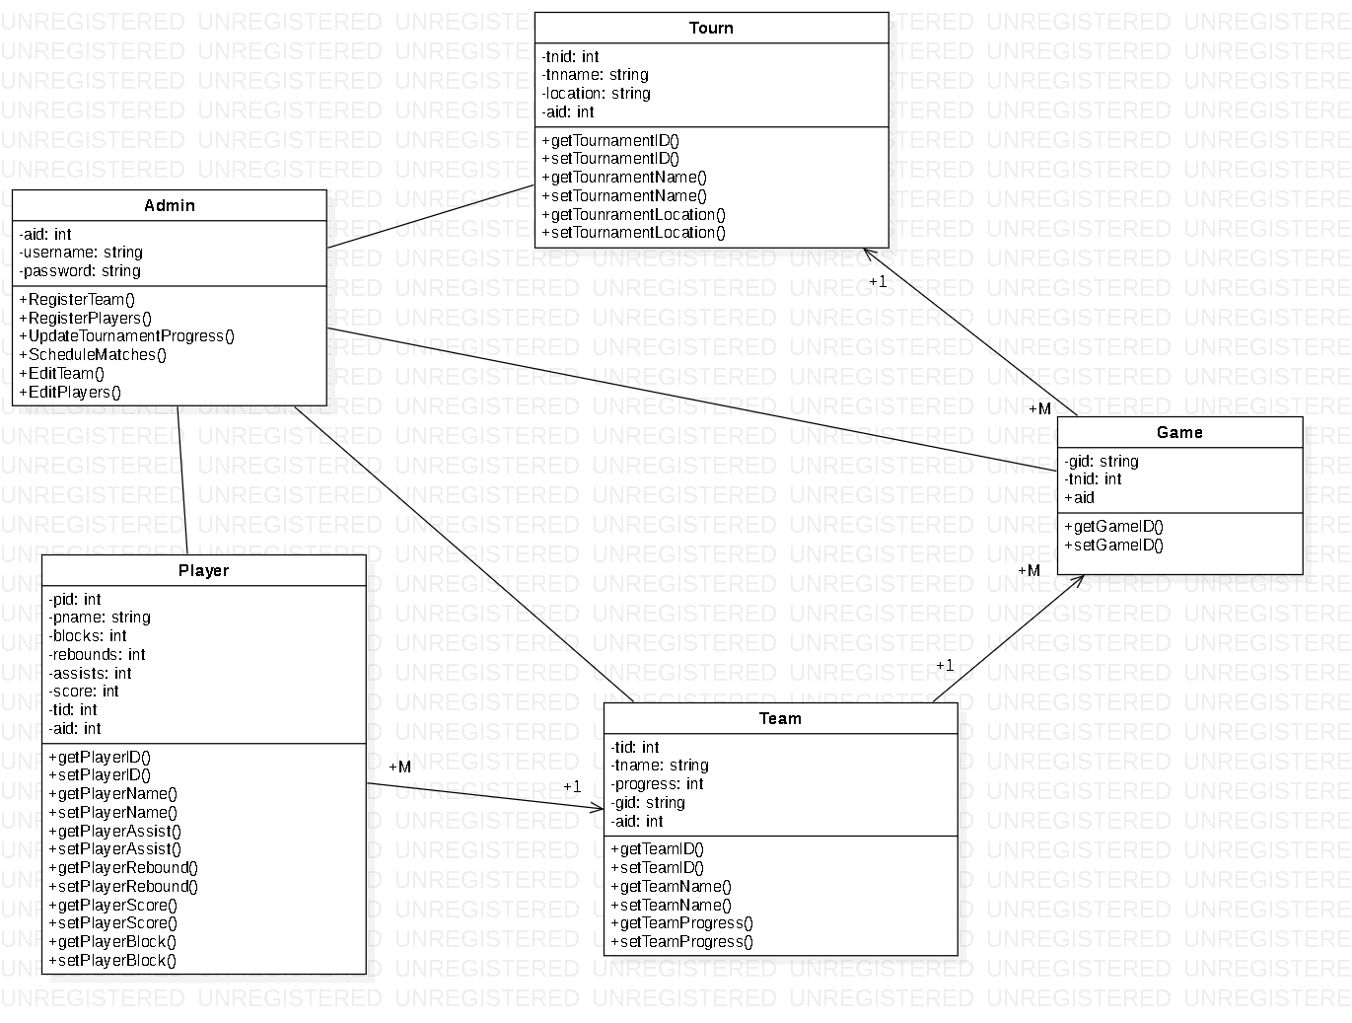

Figure: Final Class Diagram

Justification and explanation

I have created or developed my class diagram with thorough examination and is able perform for the project.

My class diagram has 5 classes i.e. Admin, Players, Team, Game and Tournament.

Notations Used

Classes: Helps to separate objects and attributes

Association: Helps to view the relationships between entities

Attributes: Defines the class

Access Modifiers: Sets the protection level for different attributes and methods.

Flowchart

Flowchart is a step by step chart process which shows the functions along with outputs, inputs and decisions. It is a very simple chart used by many although it’s a quite old process.

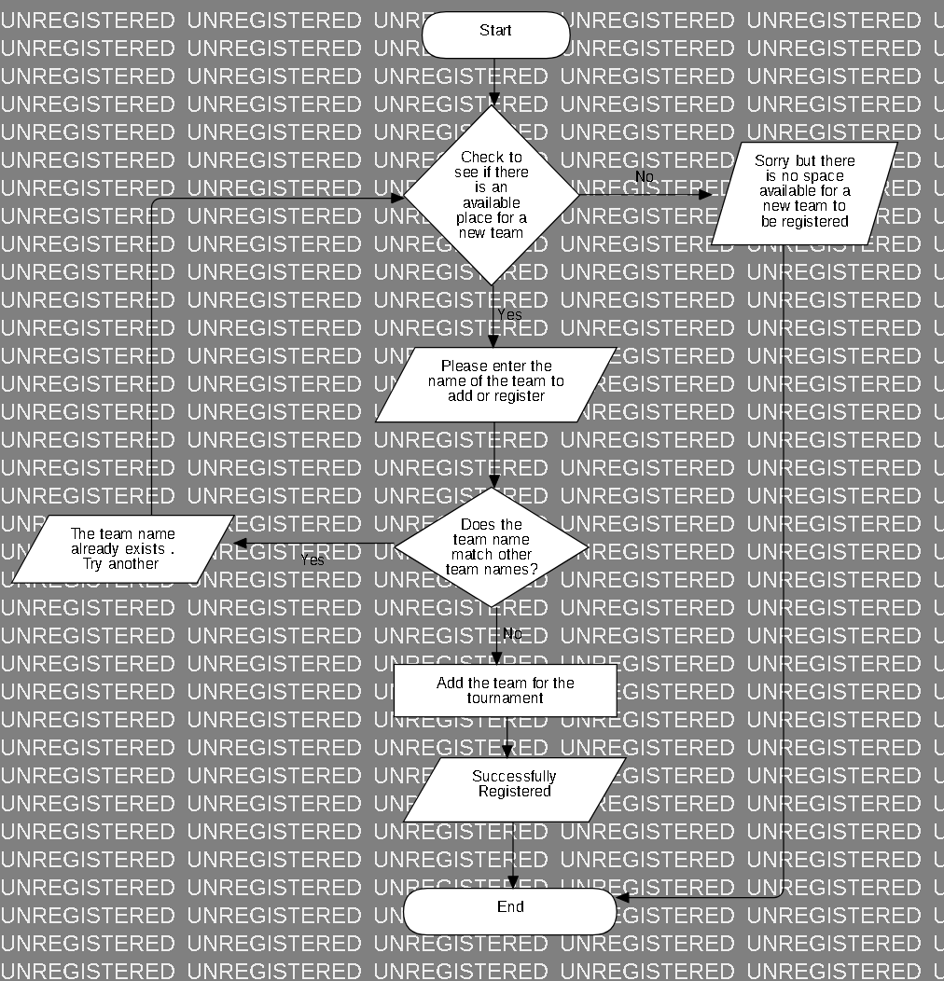

Figure: Adding teams for the tournament

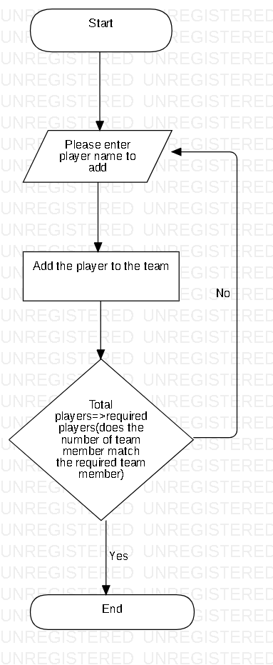

Figure: Adding players to a team

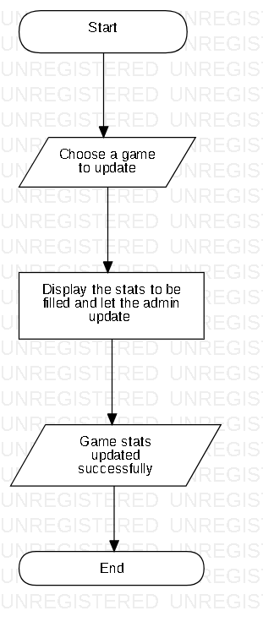

Figure: Updating Tournament Progress

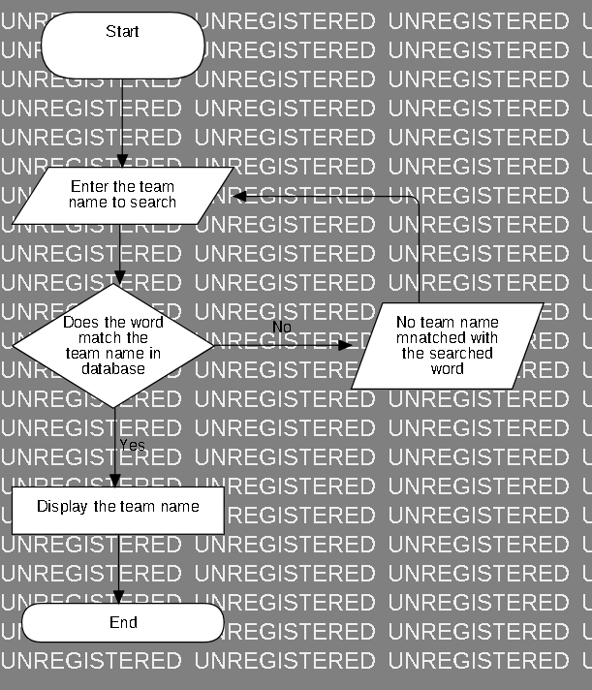

Figure: Search Team Names

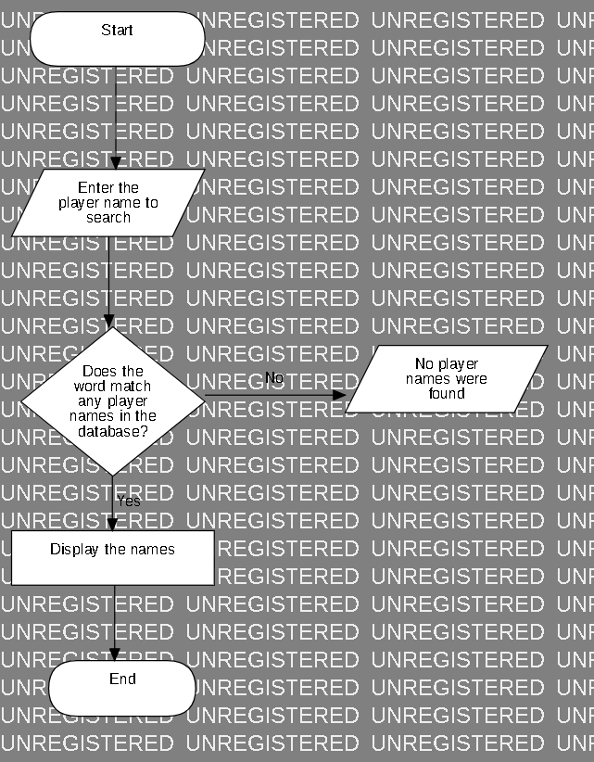

Figure: Search Player Names

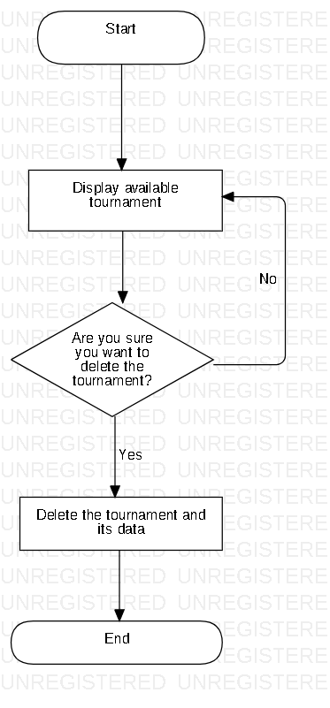

Figure: Deleting a tournament

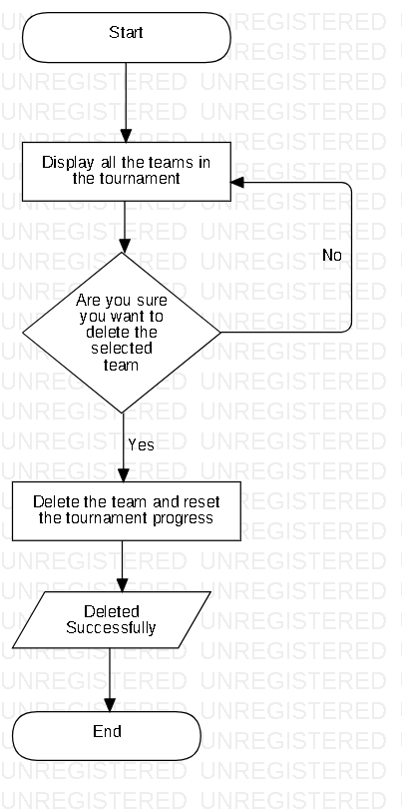

Figure: Deleting a team from a tournament

Justification and explanation

Here, I have shown the process or tasks carried out by the admin in flowcharts which shows the steps clearly and decisions which cannot be carried itself. It consists of the admin deleting tournaments, loading saved tournaments, updating tournament progress etc.

Notations Used

Flow: It lets process continue to next step

Terminator: It starts and ends the flowchart

Process: It consists of process that is carried by the system

Decisions: It helps to act according to conditions

Data Dictionary

Data Dictionary is that which consists of information able to define the structure and format of a database. It can also show relationships between elements

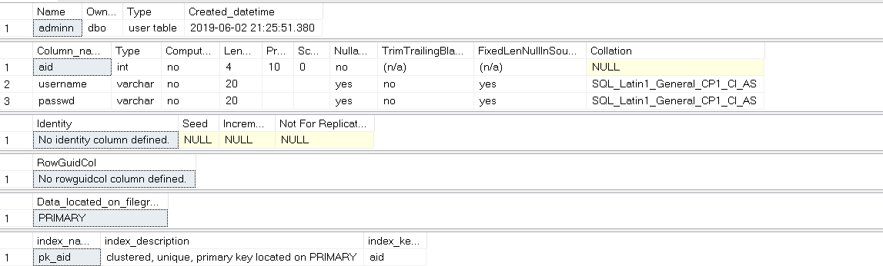

Figure: Data Dictionary of Admin

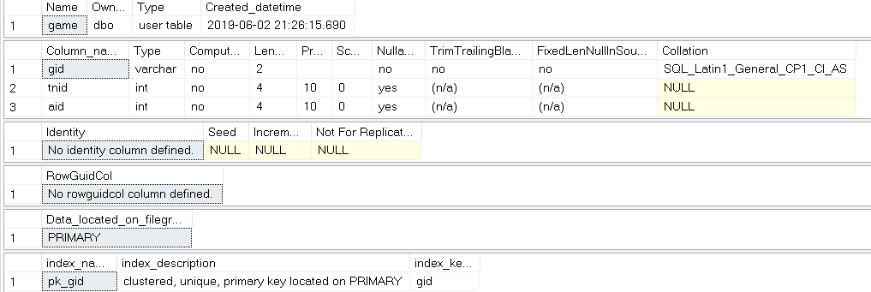

Figure: Data Dictionary of Game

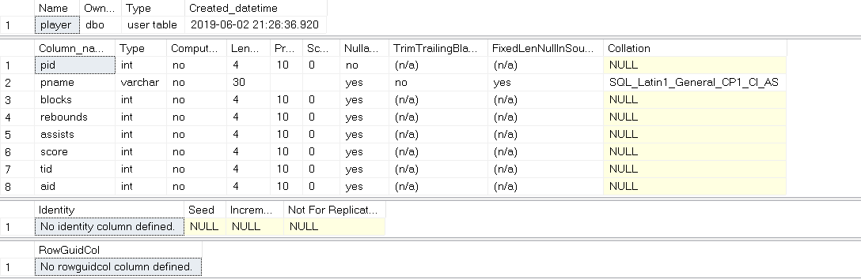

Figure: Data Dictionary of Player

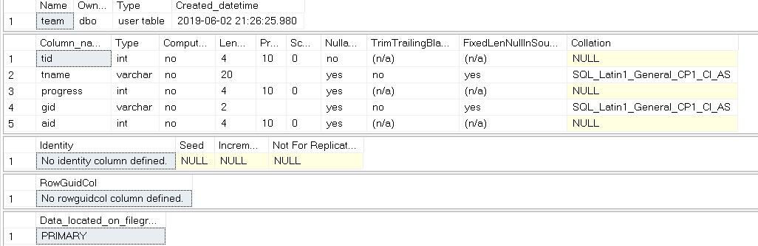

Figure: Data Dictionary of Team

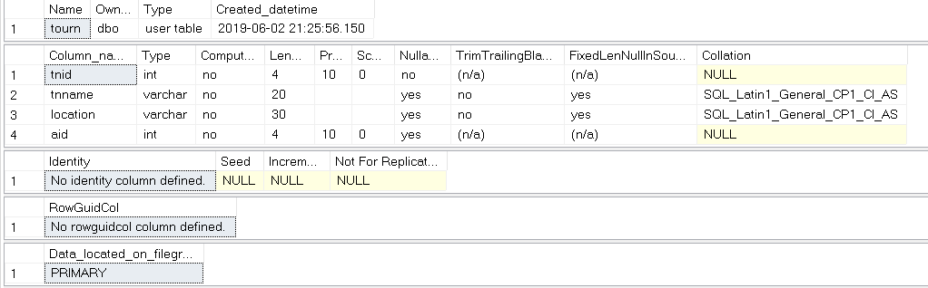

Figure: Data Dictionary of Tournament

I have shown data dictionary for all 5 entities or tables which shows data types of attributes and other information. Proper data types are given to each attributes.

Notations Used

Attributes: It defines the table or entity

Data types: It sets the attribute type

Row: It lets data exist in row wise

Column: It lets data exist in column wise

ER Diagram

ER stands for Entity Relationship which shows relation between entities as the name suggests. It helps us to study on how things work or which entity depends on whom. It can be defined as a graphical representation of an information system.

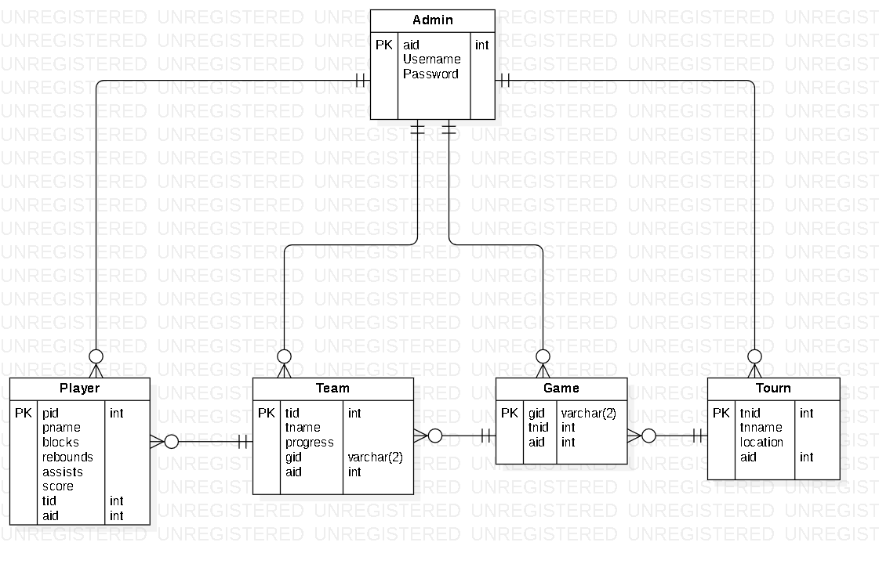

Figure: ER Diagram

Here, I have shown the relationship between each entities in the diagram which helps us in the understanding of how things work. The entities I have used are admin, player, team, game and tourn (Tournament).

Notations Used

Entity: Stores attributes and their data types

Relationships: Helps to identify relation between entities

Attributes: Helps to define the entities

Data Types: Lets certain and suitable data only to be inserted to certain attributes

Behavioral Design

Behavioral design is that which focuses on the requirements of a user or helps to communicate between objects. Activity diagram and Sequence diagram are examples of behavioral design which shows how things work between user and system.

Activity Diagram

Activity diagram shows how the activities are carried and coordinated in a system. With the help of the activity diagram, we are able to see the flow of different operations.

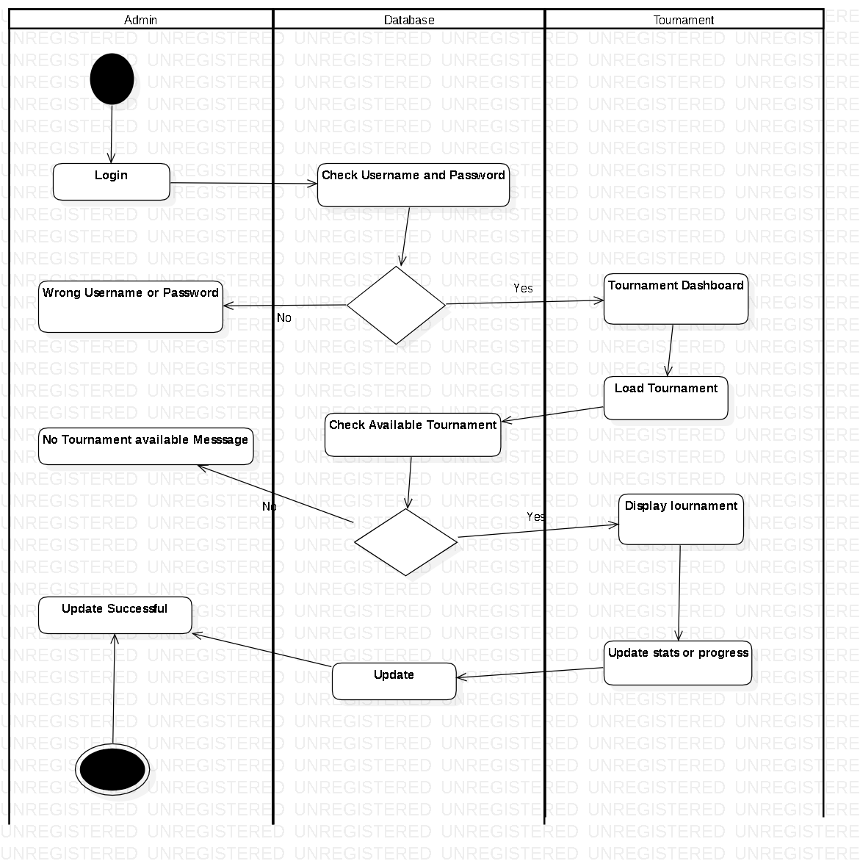

Figure: Activity Diagram

I have shown the activity diagram of the system which requires login for the administrative privileges or simply to proceed. Tournaments can be update and deleted which are shown in the diagram.

Notation used:

Action: It shows the action performed.

Swimlane: It separates and helps to identify objects.

Initial: This shows the beginning of the operation.

Final: This represents the end.

Decision: This helps when things could go either way and helps to choose.

Explanation

The Admin first logs in which is checked in the database if the login information matches and if it does then he/she is able to proceed and move to the next step of either deleting, loading or creating a tournament.

Sequence Diagram

A sequence diagram shows the interaction of objects in time sequence which helps to find which object performed more and which had least to do.

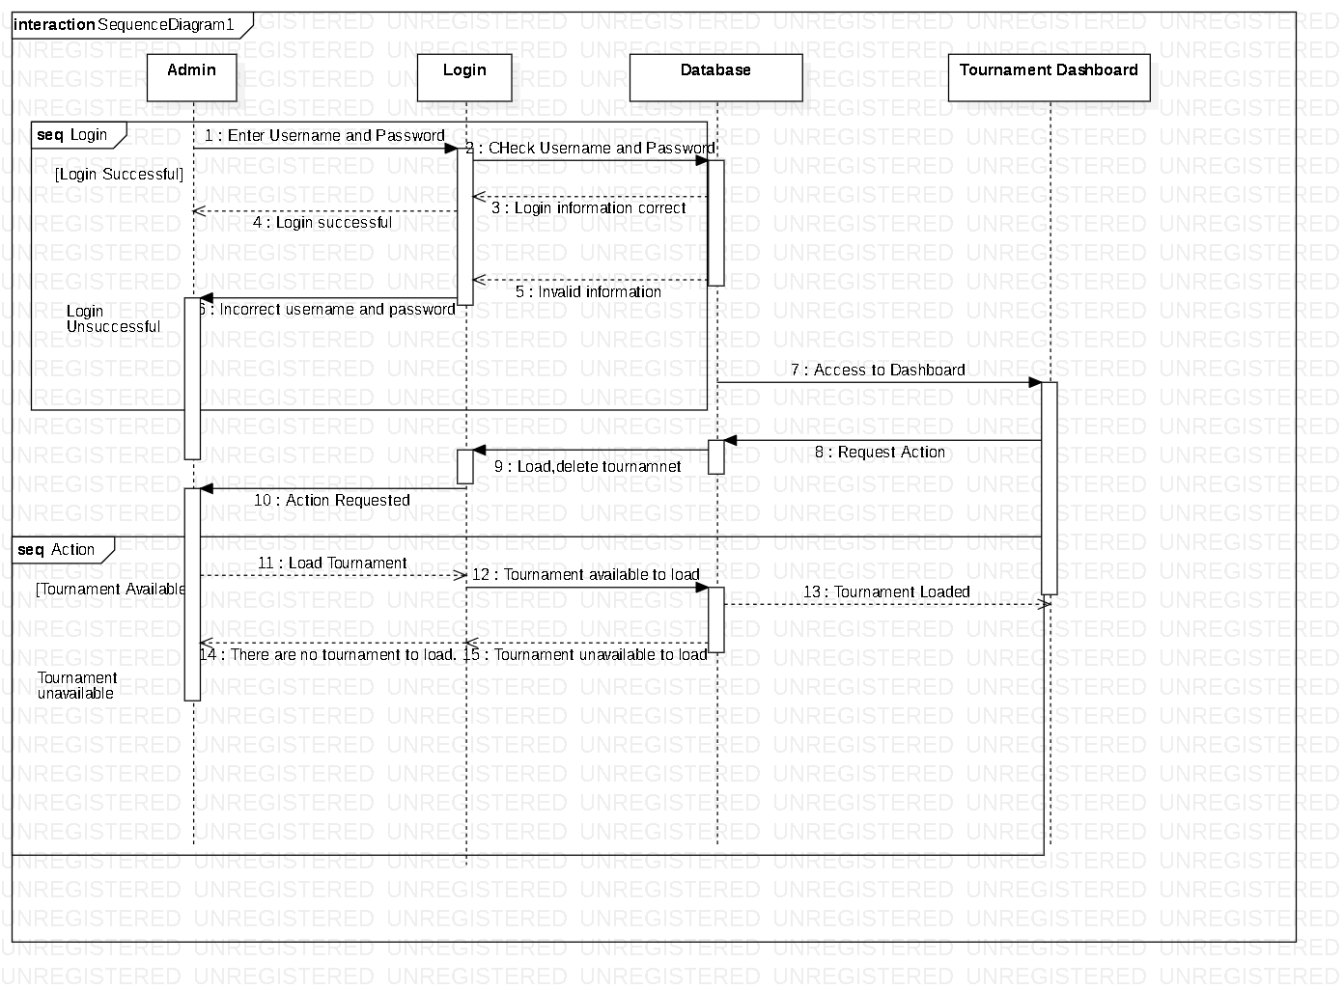

Figure: Sequence Diagram

I have created a sequence diagram which shows the actions performed by each object and their time period.

Notations Used

Lifeline: This shows the interaction and length of the operations.

Message: This shows the message sent.

Reply Message: This shows the reply received

Combined Fragment: It helps to act upon conditions.

Explanation

Admin login is required and the information are checked. If the login information is correct, the admin can proceed. However, if incorrect information is given error message is shown.

Prototyping

Prototyping is the process gone before actually implementing or starting the actual project to get proper results and avoid confusions.

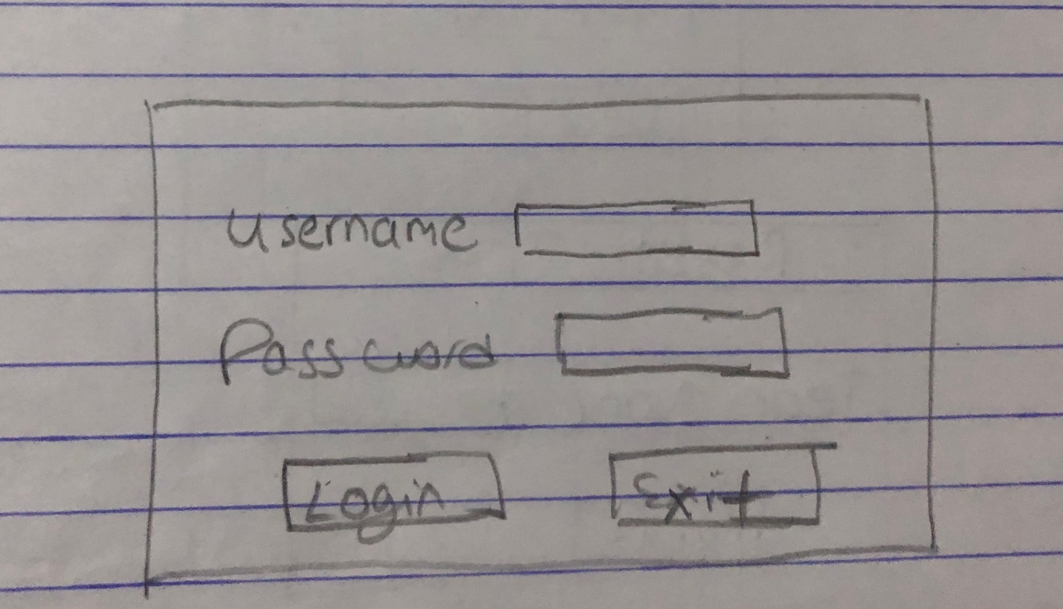

Figure: Admin Login

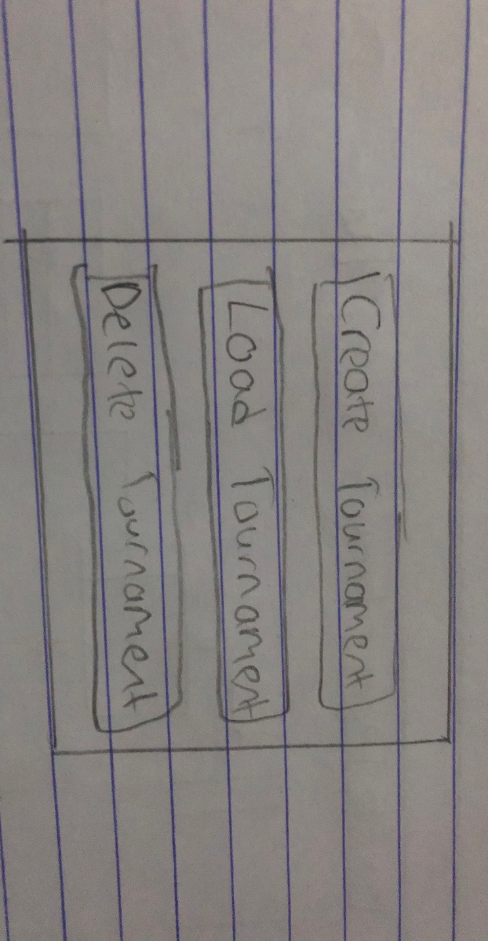

Figure: Tournament menu

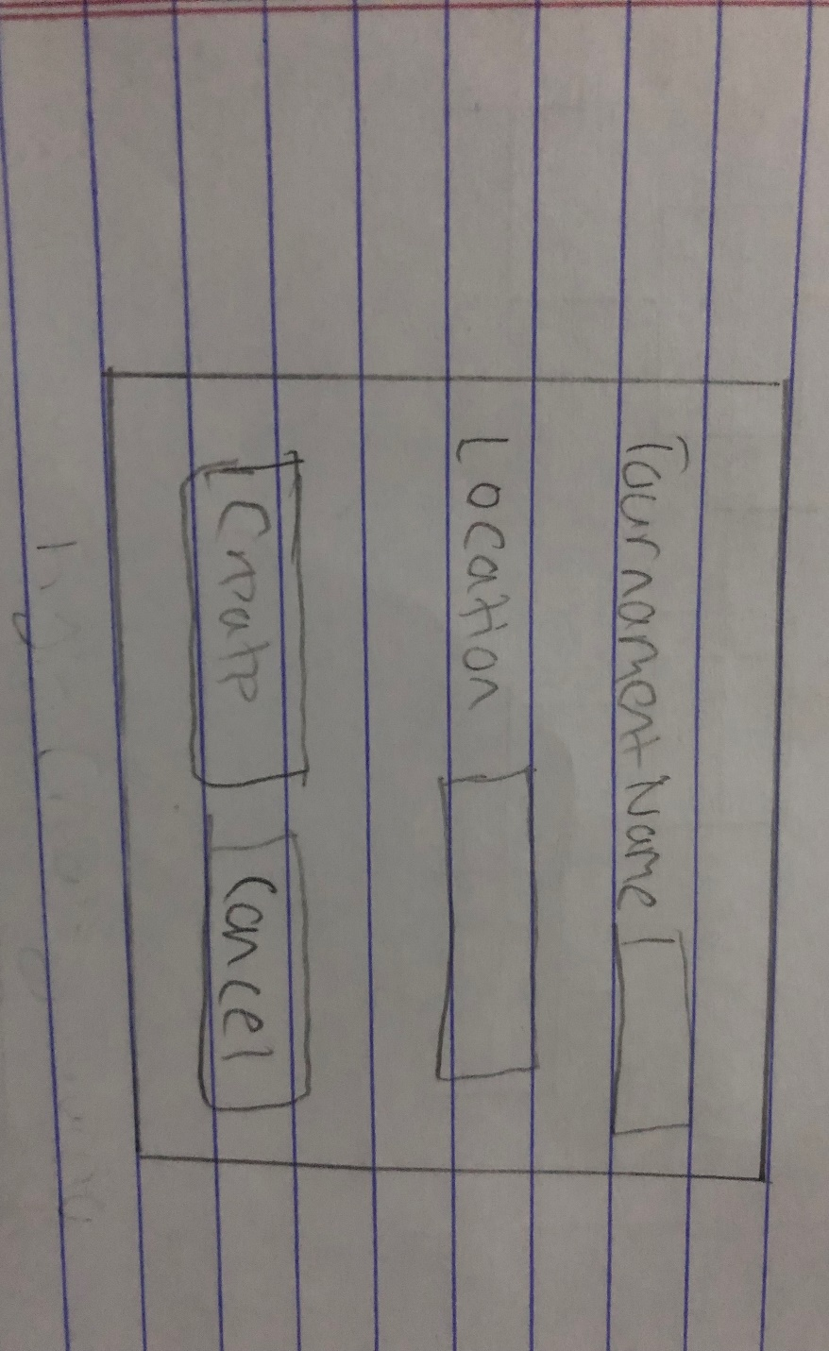

Figure: Create Tournament

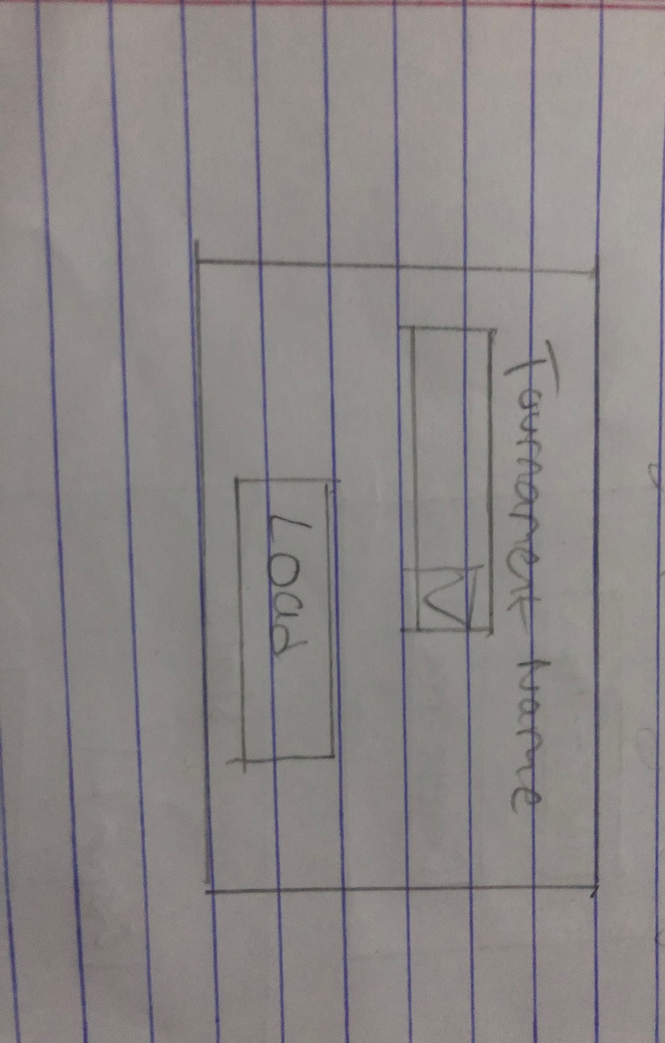

Figure: Load Tournament

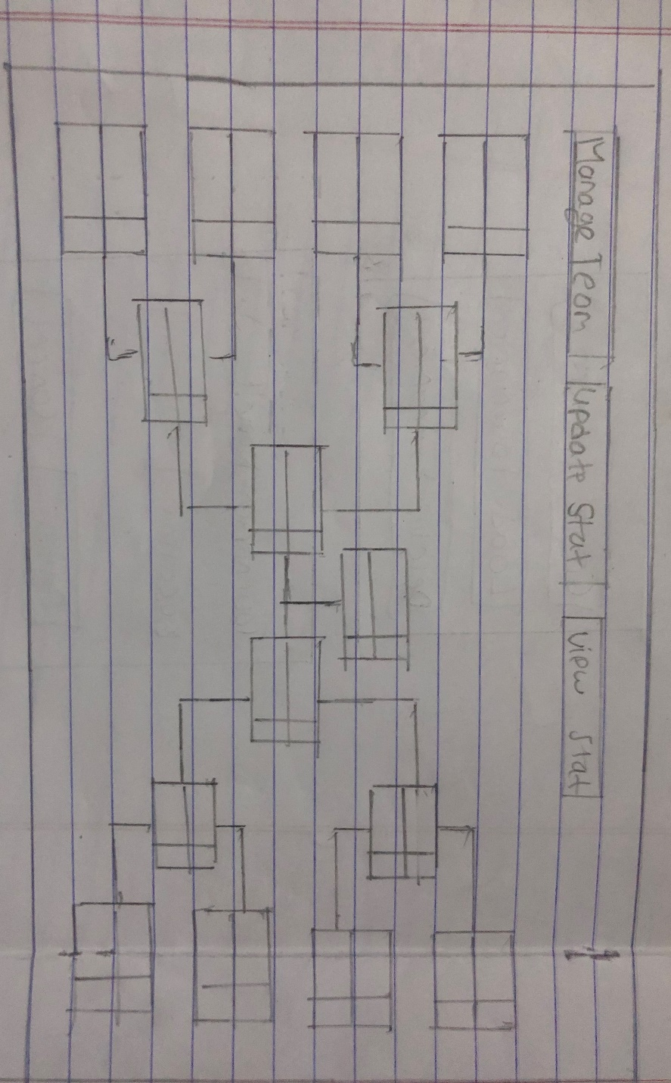

Figure: Tournament Progress

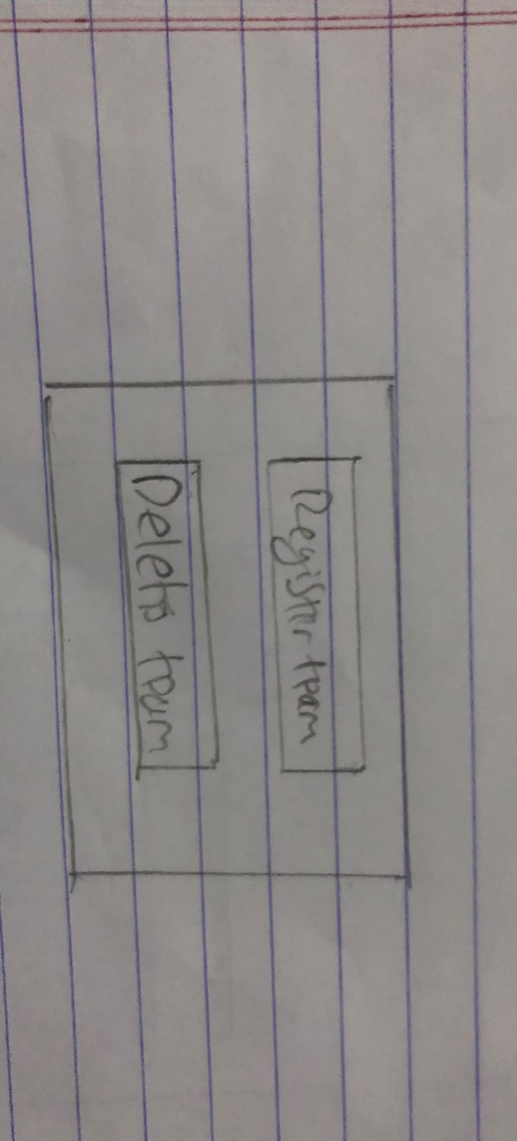

Figure: Manage Team

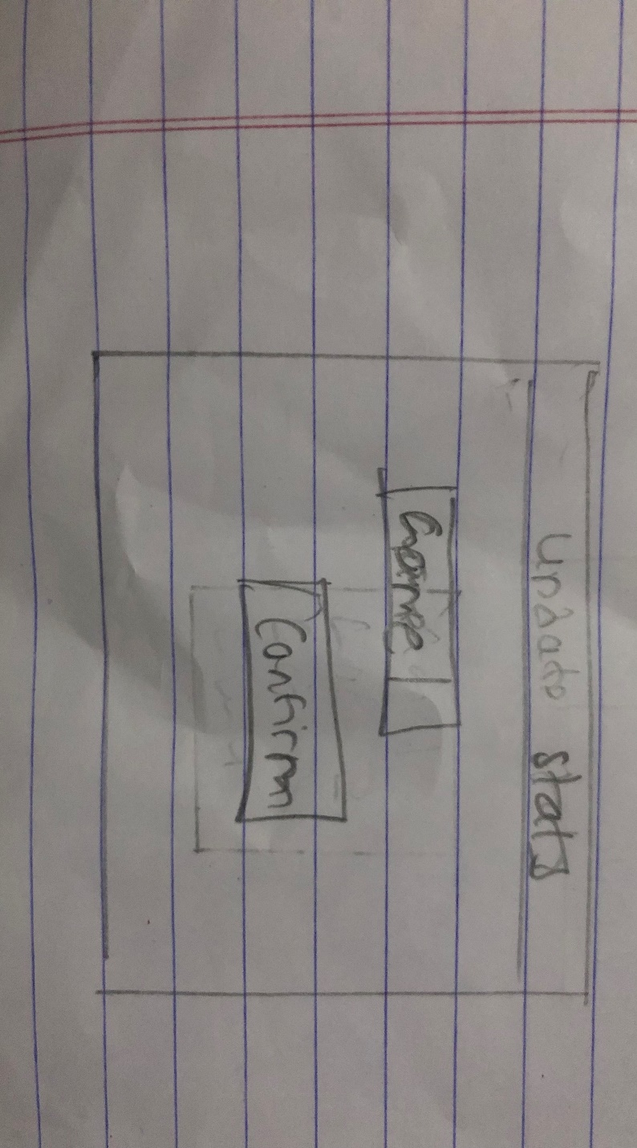

Figure: Select Game to Update Stats

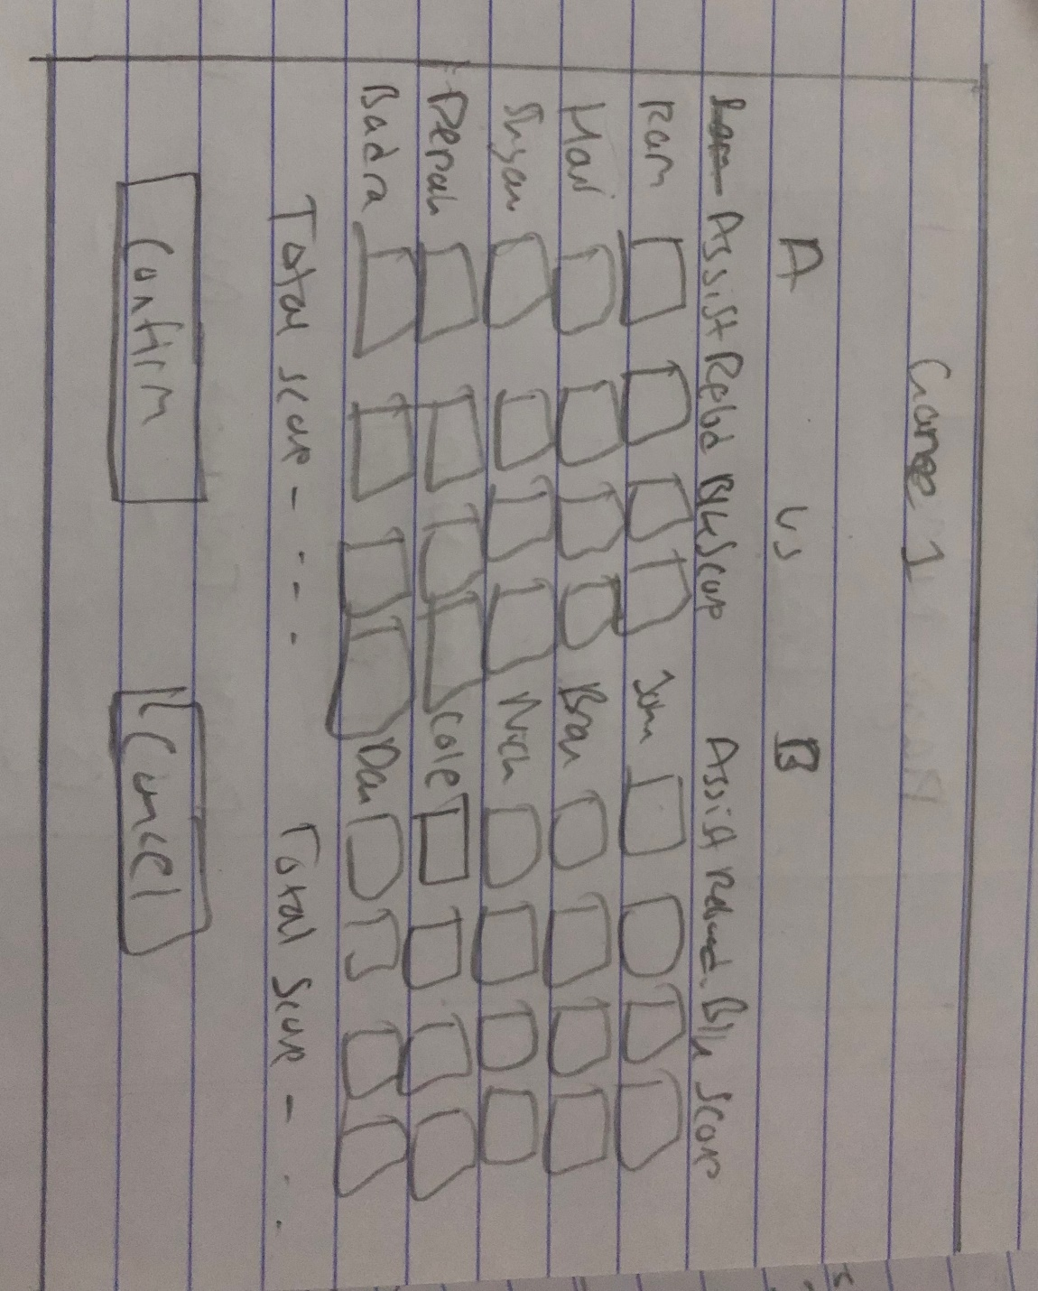

Figure: Update Stats

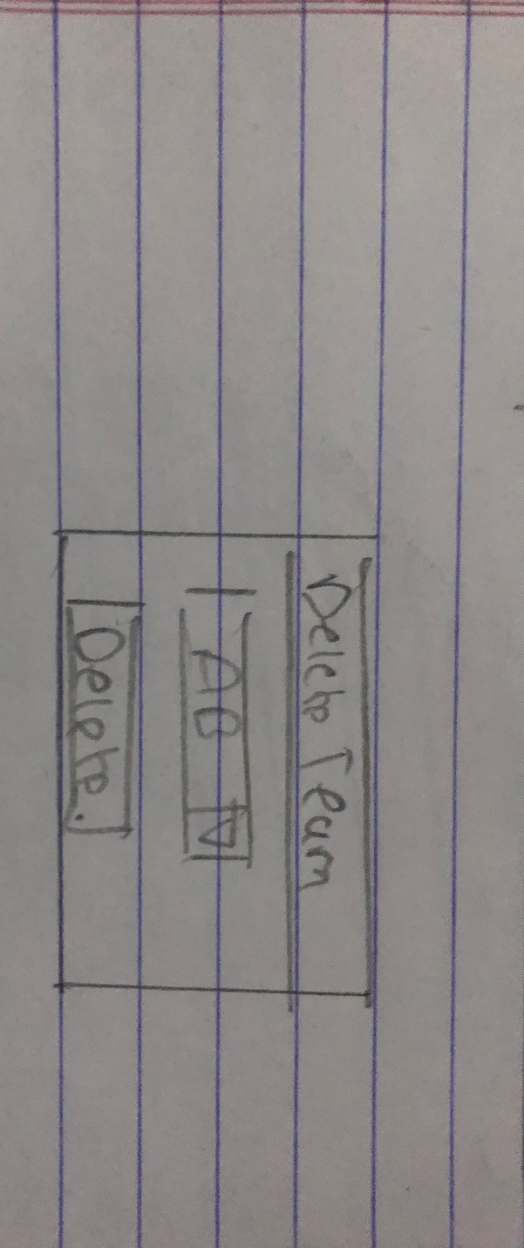

Figure: Deleting Teams

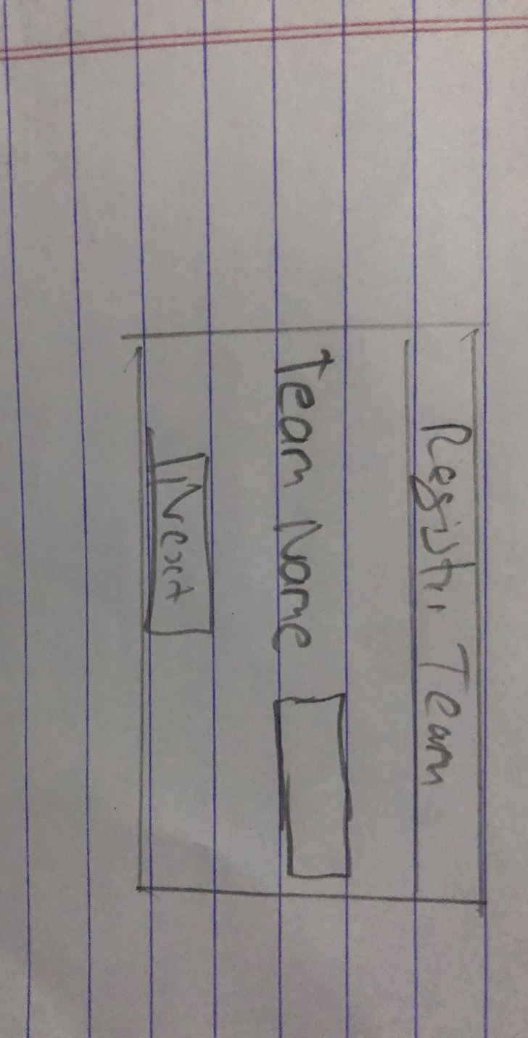

Figure: Register New Team

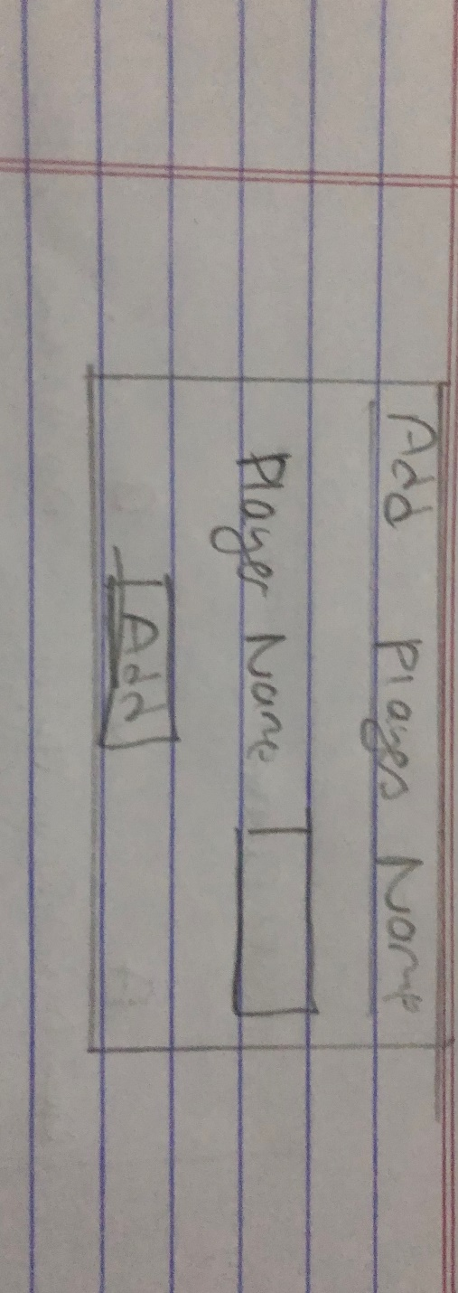

Figure: Registering Players for a Team

Justification and explanation

Here, I have shown rough diagrams which are required for the project to work. It consists of admin login, different options for tournament and the ability to update and view the progress.

Notations Used

Windows Form Box: For inserting objects

Button: To perform actions

Textbox: To insert information